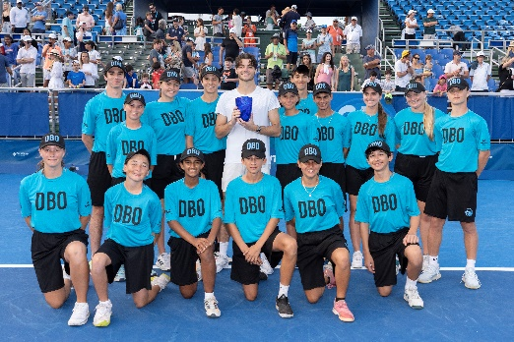
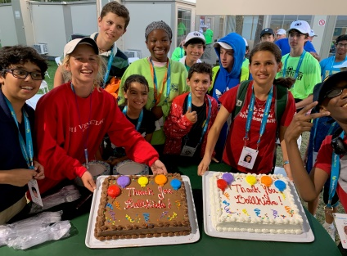
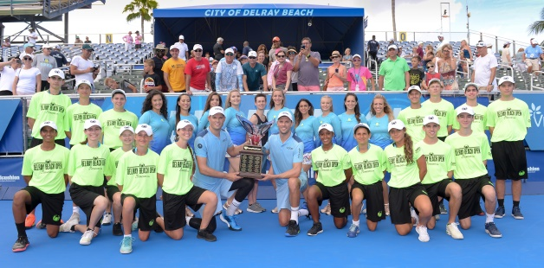

Dear Prospective Ball Person:

The 2024 Delray Beach Open will be held at the Delray Beach Stadium & Tennis Center, February 9 – 18 and features the world’s only 10-day tennis event consisting of the below:

- ATP CHAMPIONS TOUR EVENT (Feb. 9 – 11, 2024) featuring former tennis greats such as the Bryan Brothers, Tommy Haas, Sam Querrey, the Jensen Brothers & more.
- ATP WORLD TOUR EVENT (Feb. 12 – 18, 2024) featuring top-world ranked ATP Professionals such as Taylor Fritz, Tommy Paul, Cam Norrie, Denis Shapovalov & more.

We are very proud of our ball person team here at the event and know that if you are selected, you will have a wonderful experience in teamwork with us. This email contains FOUR (4) documents: Cover letter, APPLICATION, release form, and waiver. Make sure you print out all 4!

Your volunteer package will include clothing, meals, parking tickets (for those who drive) and of course the best seat in the house -- ON COURT! Each ball person will receive 2 complimentary GA tickets for each session worked.

Completed applications must be returned to me by JANUARY 20, 2024 . Photo ID badges are required. Please enclose TWO PASSPORT OR SCHOOL PHOTOS ONLY with your application. Please put your
NAME on the back of pictures and MAIL your application, release and waiver with your TWO photos to:
Monica Sica, 12926 Briarlake Dr. #103, Palm Beach Gardens, FL 33418. Faxes/emails are not accepted nor will any applications without release and pictures attached. I appreciate your cooperation with this.

Mandatory Training/Tryouts Sessions
Sat., January 27th, 11:00am - 1:00pm, Sun., January 28th 1:00 - 3:00pm and Saturday, February 3rd, 11:00 AM to 1:00 PM at the Delray Beach Stadium & Tennis Center (201 W. Atlantic Ave.). Experienced ball persons (2 or more DBO tournaments) need only to attend one session. First time ball persons (no experience) are required to attend all 3 sessions, and ALL OTHERS are required to attend two sessions. EVERYONE returning an application needs to attend a training/practice session(s).

Uniforms and Schedule Pick-up
Sat., Feb. 3rd, 2024. Immediately follows the training session, upstairs in the clubhouse. (Pro shop) We look forward to a great tournament and seeing you at the practice sessions. If you have any questions, please email me: ITCBallkids@aol.com or call at (561) 866-6433, preferably email,

Monica ~
Monica Sica, Director of Ball Persons

